Lesson 2 Building a Static Website with Amazon S3

Alen Ovalles

Purpose

The purpose of lesson 2 is to configure an Amazon S3 bucket to host a static website for BitBeat, the made-up company designed for Amazon labs. We will need to enable the Amazon S3 bucket for website hosting and to set permissions to allow the general public to view the website.

Process w/ Pictures

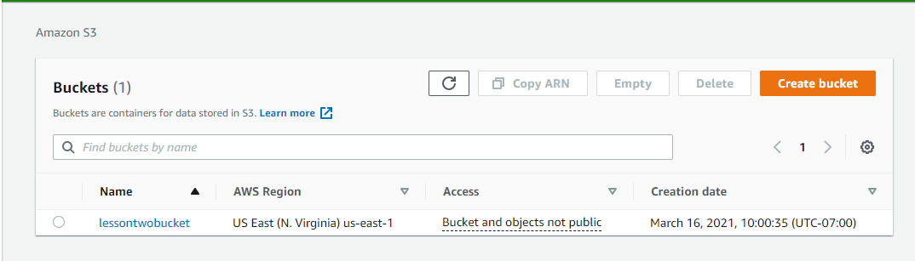

1) Create an Amazon S3 bucket



2) Enable website hosting

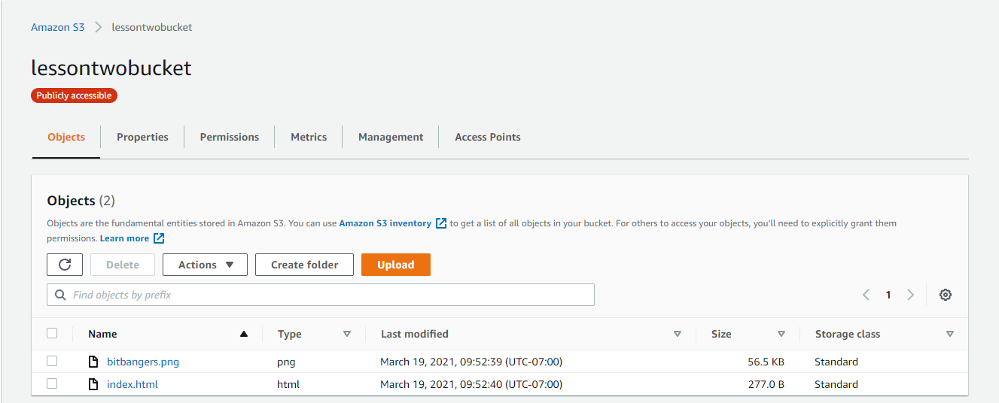

3) Upload website files to the Amazon S3 bucket

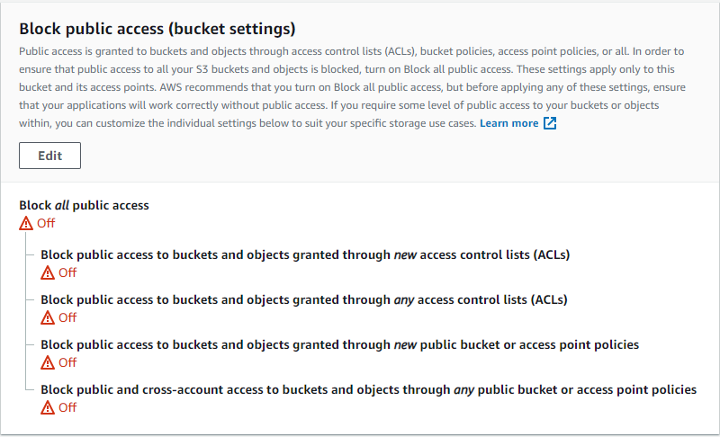

4) Set up public access permissions

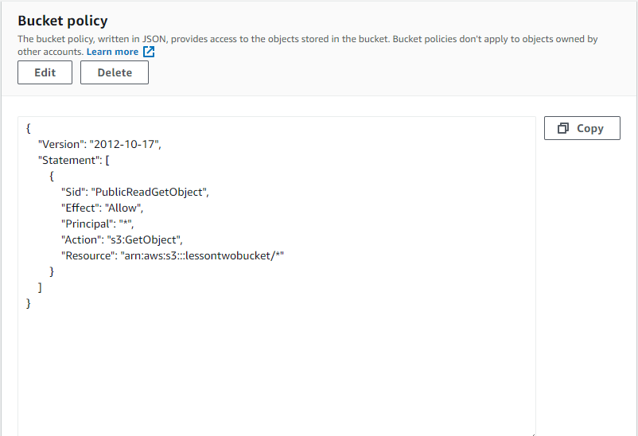

5) Add a bucket policy



6) Test and troubleshoot public access to the Amazon S3 bucket | <http://lessontwobucket.s3-website-us-east-1.amazonaws.com>

Problems

One minor problem that came up was the wording within the pdf that didn’t line up to what was on the AWS management console itself. The part where we had to download then import the downloaded files into the bucket. The pdf had the words “open the bucket management page” while the console only had an upload object tab which was supposed to be the same thing. Could have been an outdated pdf of the lesson. Another problem was having the right files in the bucket, the first time I put the png and HTML files in the bucket; the end result was an endpoint 404 error with a white blank screen. The problem later found out due to having class the next day as we had to export the zip file that downloaded and then using the export files of the png and HTML for the bucket to have.